A Tale of Two Sluggers : Juan and Eli



Tasks:

1) Study the images below, then answer the questions

2) Once you’ve completed the questions, complete your tee-work, keeping what you’ve learned in mind.

3) After completing your tee-work, submit the saved document to your coach via email.
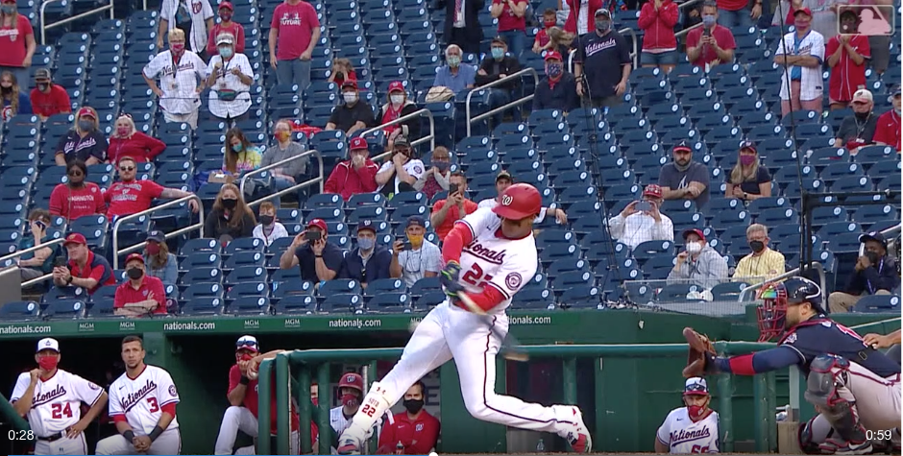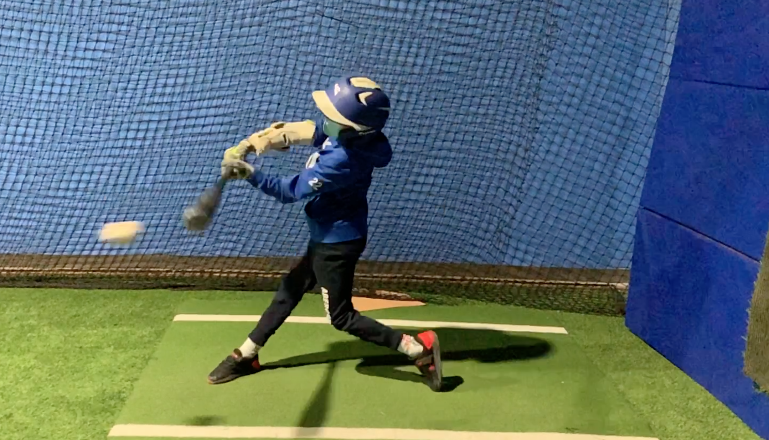

Both hitters are just at the point of impact – Juan just before, and Eli just after – how can Eli improve his swing so that when he reaches impact, the ball will be crushed?
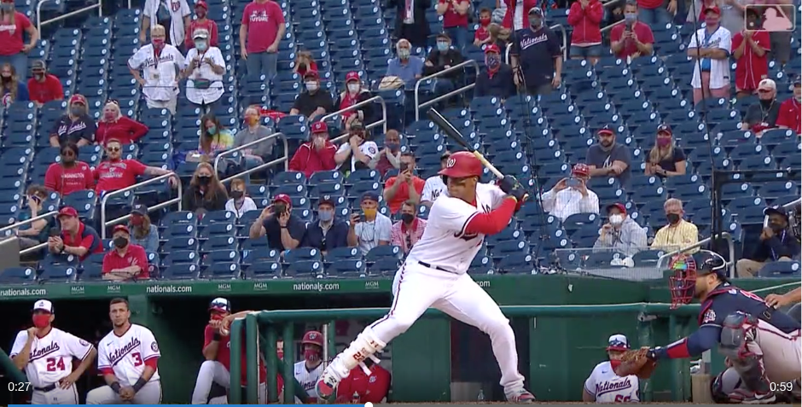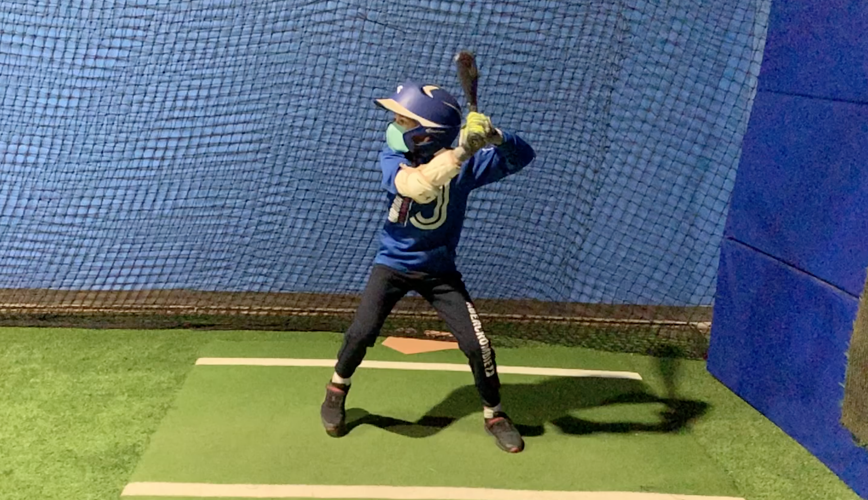

What Eli do to improve his stance as he prepares for the ball to cross the plate?

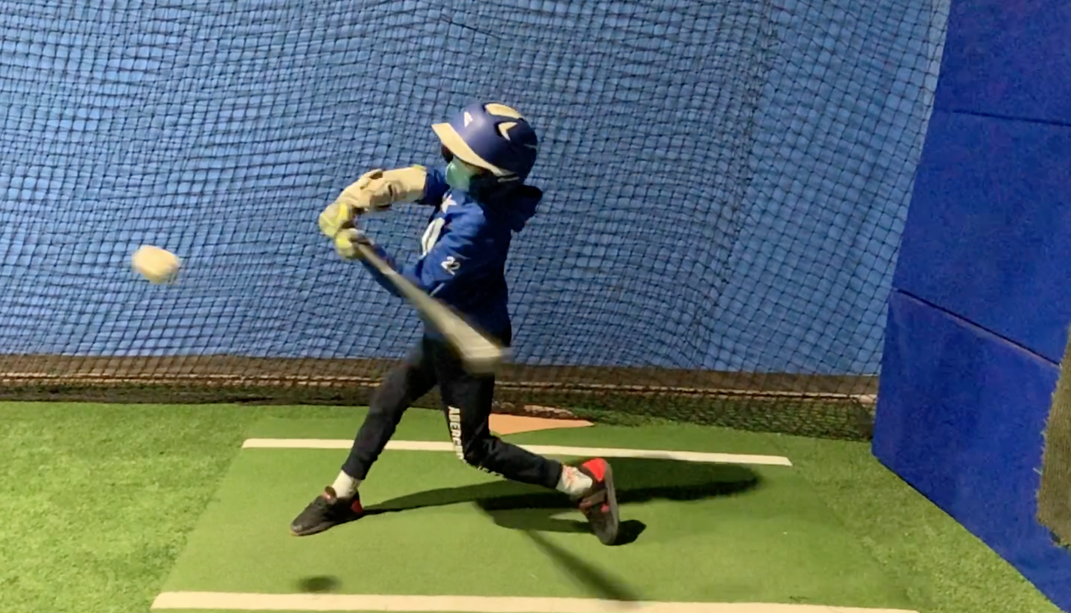

Both sluggers are about to hit the ball. How does Eli’s approach toward the ball differ from Juan Soto’s?

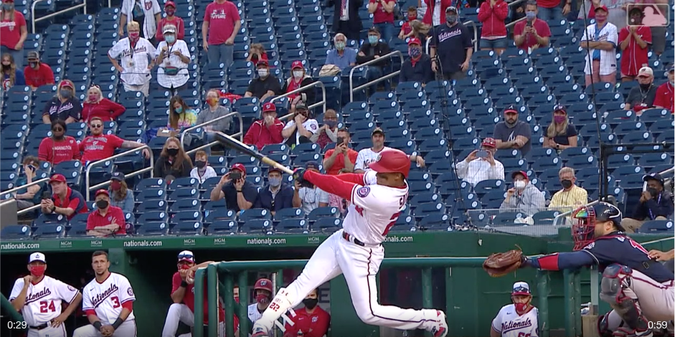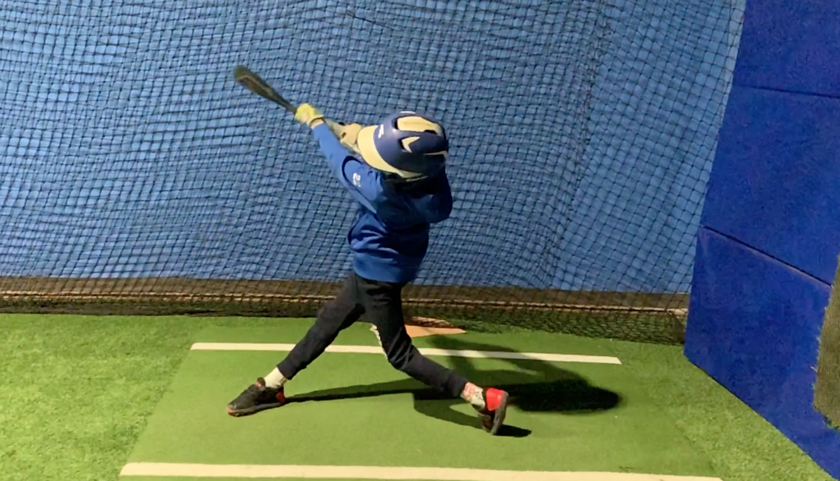

The after-swing. Eli does a fantastic job extending his arms. Any tips or comments on how he can finish more like Juan?

Final Question: One of your teammates is just about to head to the plate – bottom of the 9th, two out, game on the line. He’s been struggling with his swing of late. Keeping today’s assignment in mind, and remembering that he’s trying to get that sweet Juan Soto swing onto the ball, what’s the one thing you’re going to tell him as he walks up to the plate?

